ABC SPACECRAFT PROJECT

**Detailed Design Document**

|  |  |  |  |
| --- | --- | --- | --- |
|  | Prepared By / Last Updated By | Reviewed by | Approved By |
| Name | Tejas, Gokkul | Shiney | Vishal |
| Role | Tech | TL | DM |
| Signature |  |  |  |
| Date | 20th Mar 2017 |  |  |

Detailed Design

Requirement Traceability:

Components of our Spacecraft:

Structures: Parts: Dome, Deck1, Deck2, Wings

Dome: Dome consists of American national flag

Deck1: 14 cm height and 20 cm diameter

Deck2: 20 cm height and 20 cm diameter

Wings: Span of 60 cm

Telecommunication: For radio communication between Earth and

the spacecraft

|  |  |
| --- | --- |
|  |  |
|  | | |
|  |  |  |
|  |  |  |
|  |  |  |
|  |  |  |
|  |  |  |
|  |  |  |
|  |  |  |
|  |  |  |

Assembled view of spacecraft (Prototype):

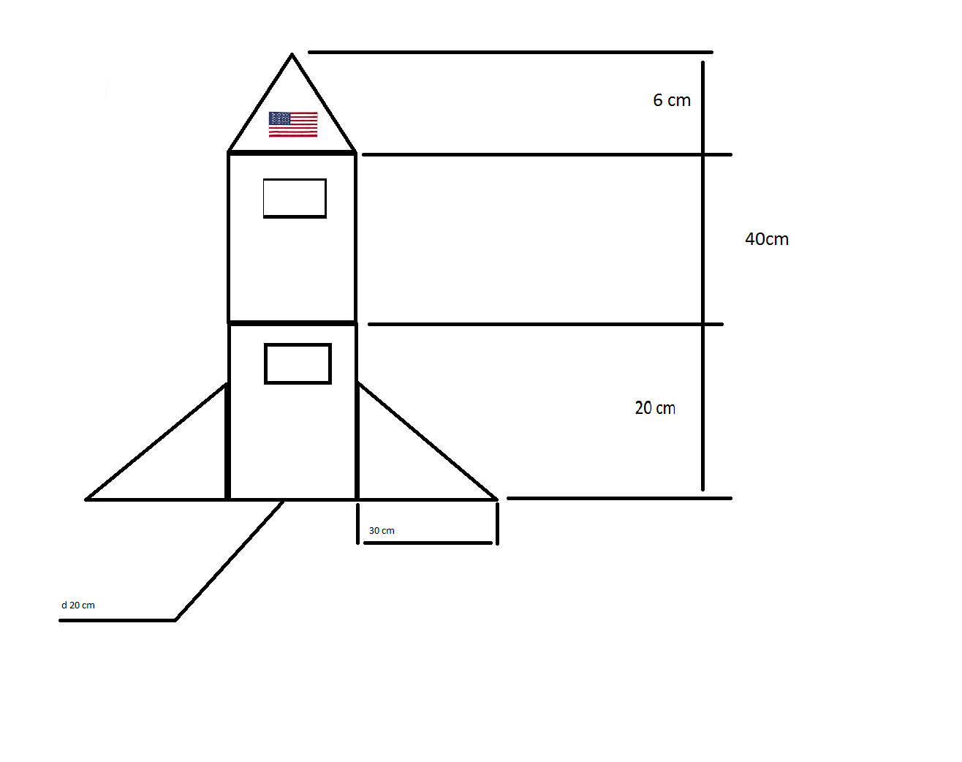

Exploded view:

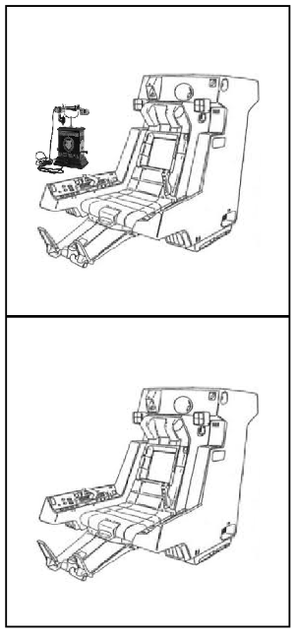

**Lower Deck**

Components:

Seat

**Upper Deck**

Components:

Seat, Telephone

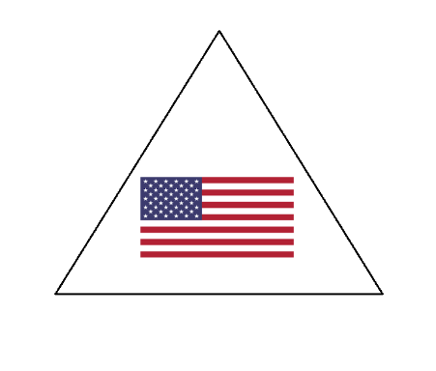

**Dome with American Flag**

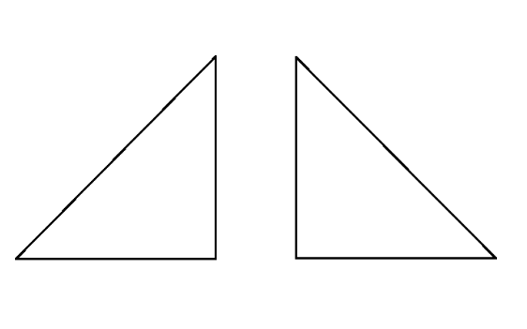

**Wings**

**Span: 60 cm**